Lesson 2:
Index:
I. Remove
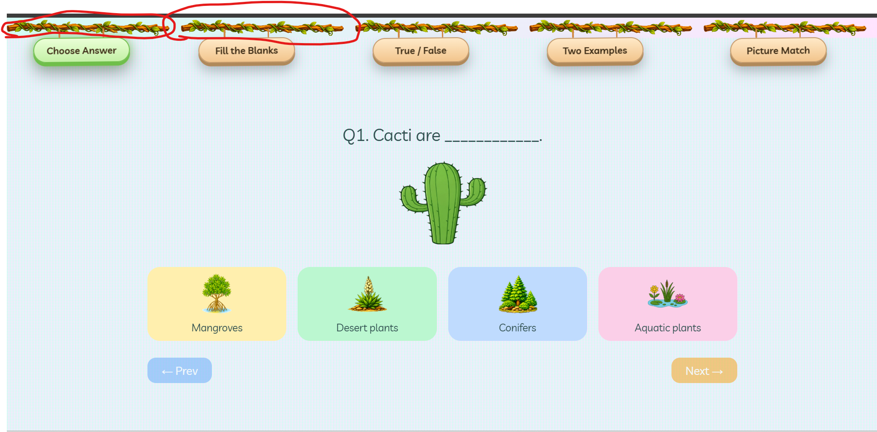
ii. Flow the excises Order as per given questions template. Lik MCQ, FIB, T/F , Matching and Two examples.
MCQ:
- On wrong and correct Answering the entire is frame is getting make it blur. Refer Grade 3 lesson1 how popup is visible on page without blurring the things

True or False:
- I should know what was answered by me. Just disable or enable not giving better identification of correct answer.
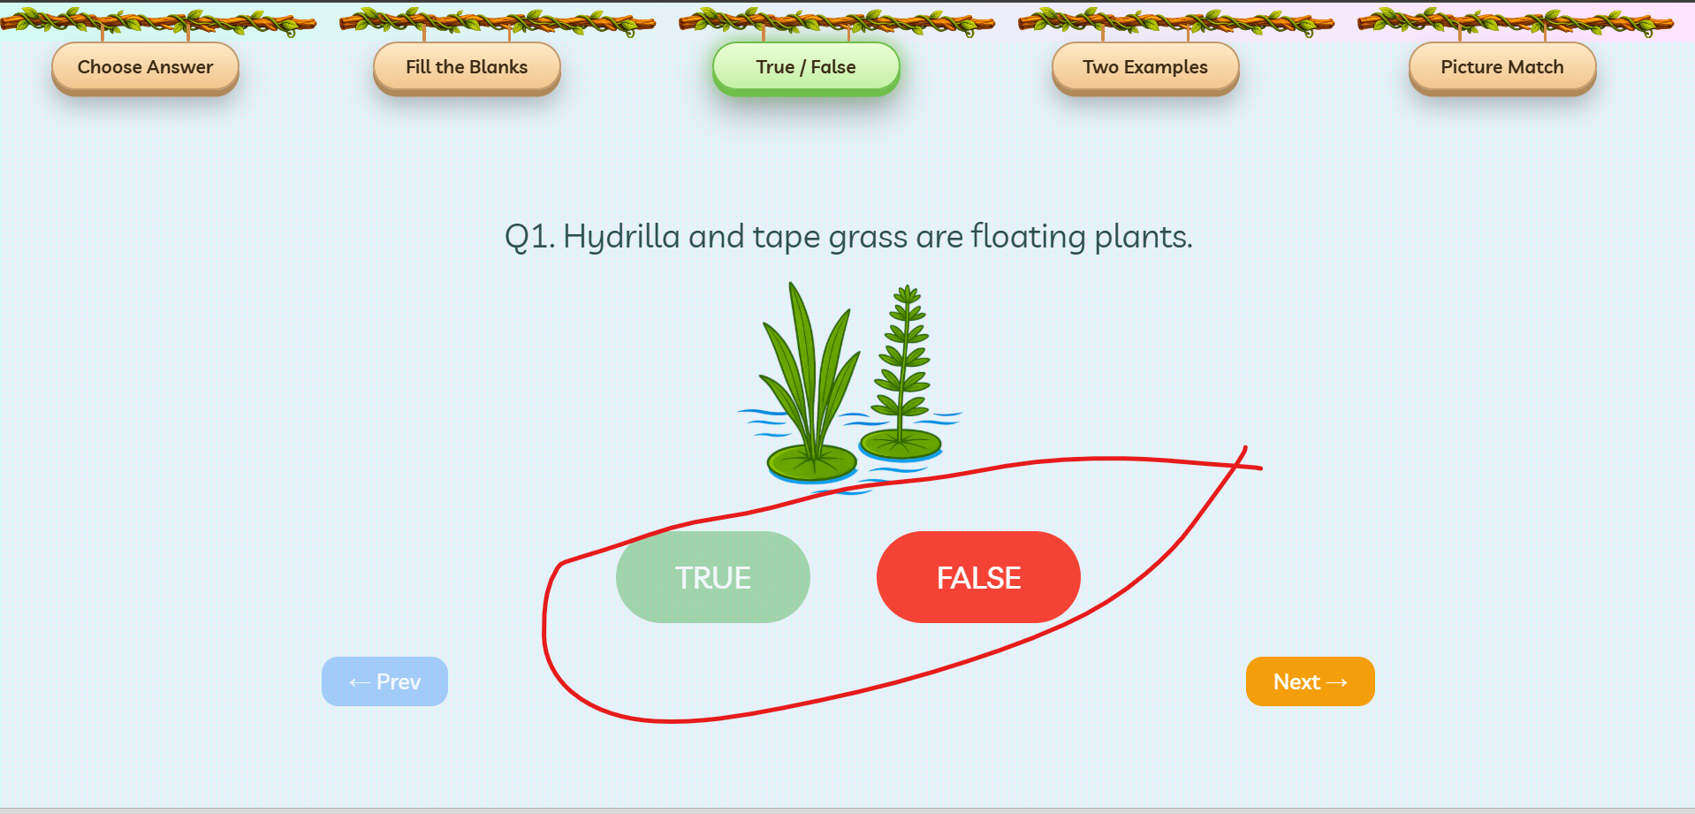
Two Example:
- Frame the question in better way or follow as per it given in the question templates.
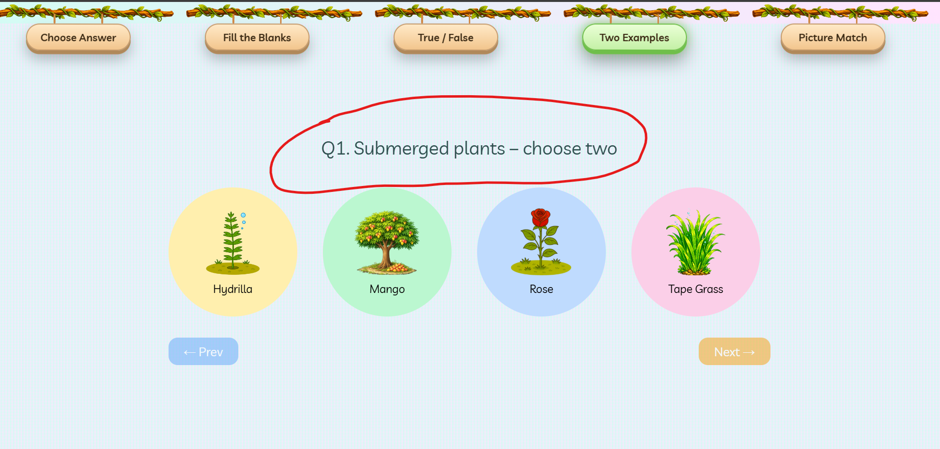

Matching:
- I’m not able to clearly identify what questions and answers got selected/matched clearly.
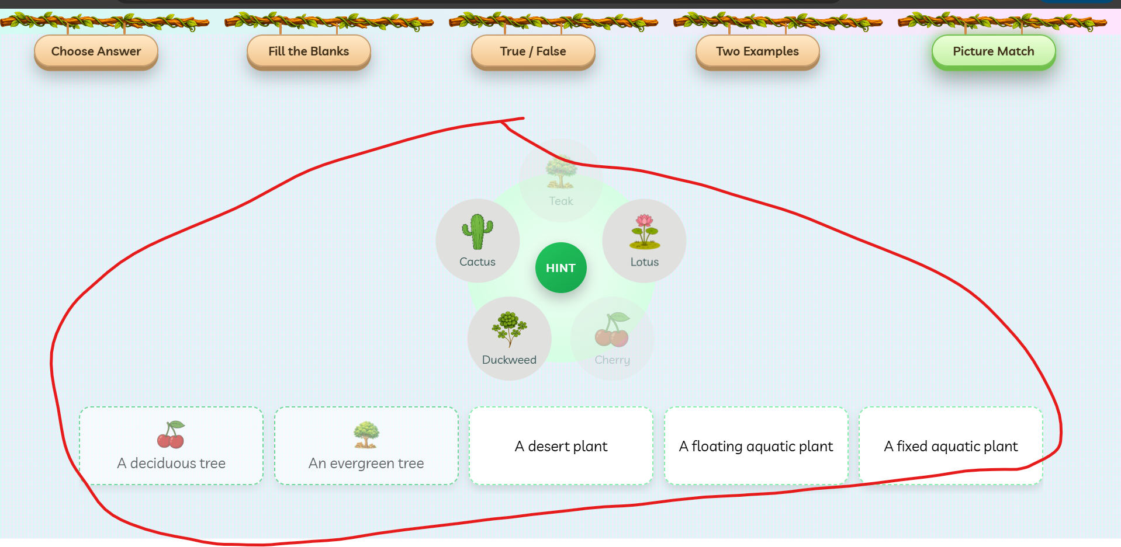
Lesson 5:
Index:

